**History and Market Overview**

Al Shiaka Company was founded in 1971 in AL Taif city, Saudi Arabia by Ali Akram AL Andejani. The company has initiated its activities under the name “Donya Al aswaf” that mainly imported high-end menswear fabrics. Within a short period of time, the company became one of the leading brands in manufacturing ready-to-wear Thobes. In 1987 the company’s name changed to “Al Shiakah” and it introduced a variety of luxury ready-to-wear Thobes in Saudi Arabia.

Classical Thobes were plain-white in color and were the only products that the company offered. People in Saudi Arabia have been wearing Thobes for many years; during that time the design of Thobes has remained largely unchanged.

**Challenges and Issues**

The high competition and the lack of innovation in the market was one of the biggest challenges that the company faced. The homogenous nature of the products created a price war, as lower prices became the only point of difference between suppliers. At the height of competition a Thobe priced at only one Saudi Riyal (less than 35 cents) lower would have the competitive edge. As a result, the company’s profit margins dwindled.

Al Shiaka was a family business. This meant that the owner made all the decisions related to the different functions of the company in a very traditional way. The different departments were not involved in decision making and did not communicate with each other effectively. This impeded the company’s expansion. Organizational restructuring and new expertise were needed in order to improve the company’s operations, especially when competing in a mature market where innovation was required.

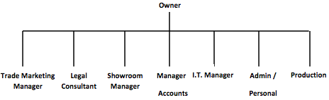

**Restructuring and Improving**

The company was now exposed to some radical changes internally and externally. They restructured the organization’s operation cycle and added some new departments to ensure quality control as well as more efficient communication between the departments. Outside expertise from companies like P&G aided the firm in resolving theses issues.

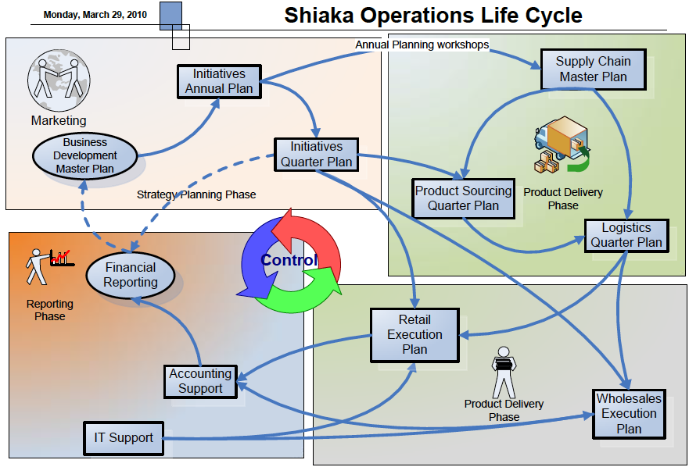

This internal restructuring helped the company to become more innovative, especially when it came to product development. As a result many new Thobe categories have been added to the company’s portfolio. The company’s mission statement was also adjusted to reflect the need for innovation as well as quality. The new mission statement became “To introduce fashion sense and creativity into traditional Saudi Thobes. To create a new level of style by reinventing traditional norms and transforming them into bold and dynamic fashion statements.” The future of the Al Shiaka Company was laid out in their new vision, “Elevating Saudi fashion through innovation and making the Saudi Thobe attractive and worn even by non Saudis.”

**Re-Thobe Brand**

In late 2007 the Al Shiaka Company introduced its first new line. The Re-Thobe Campaign by Al Shiaka was an attempt to distinguish itself in this mature market by providing a variety of new Thobe designs. These designs tended to be more sporty and casual than the classical Thobes.The company used the word “Change” as a slogan for this product, which attracted people who tended to appreciate new things. However, it also faced tremendous opposition.

**Challenges Faced by Re-Thobe**

The Saudi public was divided into two groups. The first group was the Conservatives; they were only interested in basic plain-white Thobes. Conservatives attacked the company, accusing it of trying to destroy Saudi tradition and heritage. Some Saudi newspapers covered this story from the Conservative perspective. They denounced these unconventional Thobes as not part of the culture. However, other newspapers came to the defense of these new designs, Ahmed Reda, an editor for the Saudi Watan newspaper was quoted as saying, “Some people are very scared of change, and whenever a new trend or a phenomena is introduced to the society, they don't sit back and observe it, instead they attack it, and here is where media has to step in and educate these people about the positivity of change."   
 The second group was comprised of rebellious young men who were thirsty for change and who desperately wanted to express individuality. Young Saudi boys were often interested in customizing their cars and mobiles. All of their possessions were seen as a reflection of their personalities and attitudes. A major way to express one’s self was through clothing, and that is what Re-Thobe offered.

Re-Thobe also caused the company to suffer through some operational issues. It was more difficult to convince the distributors to allocate these new designs because many of them were Conservatives who thought that it would be offensive to Saudi traditions. Some internal department heads, like Warehouses Managers and Production Managers also did not like the concept of the new Thobes. They were concerned about being able to allocate the space and organization necessary to manufacture and house all the different designs. Under the old system these managers didn’t have to worry about these issues because all Thobes were identical and size was the only difference when it came to production.

**The Al Shiaka** R**esponse**  
 Tradition is a very sensitive topic in Saudi Arabia, so Re-Thobe became a hot topic in the media. As a response to the Conservative opposition and the Progressive support, the company began a PR Campaign aimed at changing the perspective of the Conservatives and enhancing the support of the Progressives.

To resolve the internal issues, the company improved its internal communications. They adopted a more open system to discuss the concerns of the production and the inventory managers. Al Shiaka also provided sales agents and staff with additional training to ensure that they fully understood and appreciated the concept of these new Thobes and who they were targeting. They brought in a team of young guys who reflected their target market. They were cool looking guys with cool hair wearing cool Thobes. The role of marketing department was expanded and enhanced. A new marketing manager was hired and a fashion design department was added to the company’s structure. They also opened new show rooms with decorations that fit their brand and target. After all these changes were implemented distributors were finally willing to have Re-Thobe in their show rooms as well.

The company wanted to make people think of their brand as something that would bring Conservatives and Progressives together somewhere in the middle. They arranged and sponsored different events around Saudi to that end. One event in particular was quite controversial, the company organized the first male fashion show in the Saudi Arabia’s history! Al Shiakah sponsored an event held by the Jeddah boys (A well known group of young men who redecorated their cars with special kits). The event was held at the Jeddah Raceway which was basically a fashion show for customized cars. The idea behind the fashion show was to surprise the audience by having the all-male drivers walk in wearing Re-Thobes. Al Shiaka thereby allied their idea with those young guys behind the wheel who were always seeking to customize their cars. "Those young men are the inspiration of the new Thobe line. They inspired us not only by trending their cars, but also by the change we noticed in their lifestyle and attitudes" said Mr. Sami Al Zuhabi, Al Sheyaka Marketing Manager.   
 Being the first of its kind, the male fashion show was a hot topic in the local media and many newspapers covered the event. The company was able to increase awareness and promote their unique brand in a way that appealed to the target market. Unfortunately an unexpected accident occurred during the event. One of the cars caught on fire during the show. However, Al Shiaka took advantage of this crisis and turned it into an opportunity. The company paid to fix the car under the condition that it be re-branding with Re-Thobe logo. It cost over 30,000 SR but the company gained a dedicated spokesperson in the Jeddah Boys. The Jeddah Boys members and their fans appreciated the company’s proactive response. This generated positive word of mouth that was then spread over the Internet which resulted in a weakening of the criticism over the fashion show.

**Applying the Seven Principles**

The Al Shiaka Company has proven to be a successful company in Saudi Arabia. Part of their success can be attributed to applying the Seven Page Principles. This is evident when reviewing its strategies in communicating with the public.

The first principle of the Page Society is to tell the truth.  Al Shiaka has embraced integrity and accuracy when communicating with its key audience "the young and rebellious.” The nontraditional Thobe designs were frowned upon by the conservative society. Al Shiaka had to face critics who claimed that these new designs were not part of the culture. Throughout these challenges Al Shiaka stayed true to its identity by holding true to a message of change.  They stated that these Thobes were rebellious, unconventional, and unusual. Just like the company itself, these Thobes were for men who wanted to stand out and be different. By staying true to what they represent, the company built trust and loyalty with its customers and shareholders.

The second Page Principle is to prove what they say with action. The company is applying this principle in a number of ways. First, they produce a variety of creative, captivating and daring Thobe designs.  Secondly, the company has collaborated with a small local group called The Jeddah Boys who are known in Saudi for being unconventional and provocative. The Boys’ main activity is to customize cars in the city of Jeddah. Conveniently most of its customers are young with a rebellious streak. By allying itself with The Boys, Al Shiaka is proving that it has a vested interest in this Progressive lifestyle and is not merely attempting to profit from it.

The third principle is to listen to the customers. This is evident in the research surveys Al Shiaka conducts not only with the young customers but also with their mothers. In Saudi, mothers have a great amount of influence on what their teenage sons wear. It is crucial that Al Shiaka get feedback about the new designs from the mothers as well. The surveys proved to be beneficial. The mothers tend to pay a lot more attention to practical elements these new Thobes in addition to the fashionable qualities. The mothers complained about the fact that the pockets in the new designs were weak, so the company worked on improving their line by adding double stitches to help with tears. They also introduced a Thobe with pockets made of denim to further enhance the quality. This shows that Al Shiaka is ready to listen and will act on that feedback by developing new products based on customers insights.

The fourth principle is managing for tomorrow. The staff at Al Shiaka promoted the company’s growth when they took into consideration the public reaction to the company's products. While they ignored a lot of the negative media attention, they did not completely ignore the demand for the traditional white Thobe.  One of the challenging situations the company faced was when Prince Khalid Alfaisal banned the new designs from schools. He decried that students were required to wear the regular white Thobe  in all public schools. The company responded by introducing a plain-white Thobe design called “The School Thobe.” This design incorporated a simple creative twist that would still differentiate it from the traditional Thobe, they used a colorful zipper at the front instead of buttons. The new designs were still popular and were worn by students even after school was over.  In addition, the company planned ahead by introducing different lines that spoke to different niche markets. They anticipated how the fashionable Thobe market might change and therefore avoided situations that may bring conflict with the company's interest.

The fifth principle is to Conduct PR as if the whole company depends on it. When speaking with Mr.Sami Al Zuhaibi, Al Shiaka’s Marketing Manager, he stated that when implementing a strategy, his team looks at the big picture, and makes sure that each communication program\activity does not affect the company's reputation negatively on the long term. For example when they first introduced the Sports Thobe designs, the company collaborated with two local sports clubs instead of one. The marketing team took into consideration the impact of this strategy on their public. They then chose to collaborate with the two most popular sports clubs so that they wouldn’t upset the fans of either one of these popular sports clubs.

The 6th principle is to realize that a company’s true character is expressed by its people. Al Shiaka has an ethical guide for its employees and training programs are held frequently.  In addition, employees are required to wear the company's stylishly captivating Thobes during their work hours to represent the company's image whether they work in entry level or top managerial positions. The attention given to the employees shows that they play a significant role in the Al Shiaka Company.

The 7th and final Page Principle is to remain calm, patient and good-humored. Al Shiaka responded intelligently when faced with the critics' view that these new Thobes were ugly and extraneous to the community. Instead of attacking the idea of the traditional Thobe, they provided the rationale behind the new designs as something that bridges the gap between Conservatives and Progressives. Al Shiaka then became a conciliatory voice and an example of moderate thought. They stated, “we are trying to attract the young segment to wear Thobes instead of shirts and jeans by providing a variety of designs for them.”  This approach helped to soften the opposition and hinder the attacks of the company's critics.

**Conclusion**  
 As the Saudi saying goes "Tastes differ,” it is true that these new designs were out of the ordinary and some in Saudi society did not welcome them. It is evident from the media’s reviews and the company’s profits that the public admired how the designers kept the authenticity of a traditional outfit yet spiced it up with a touch of modernism. Al Shiaka has managed to communicate their idea using channels and tactics that fit their target audience effectively. More importantly, they have managed to deal with a negative public response in a smart, conciliatory way.